Never Presume & Plot to Kill Donald Trump
November 21, 2016
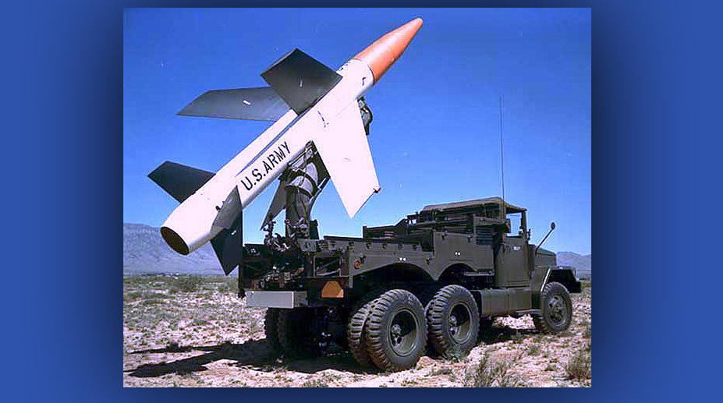
May Our Sweet Lord Jesus be ever so present to you, all dear Heartdwellers.

I’ve been somewhat plagued with distractions getting into prayer today, but finally I did.

And I just had to say to the Lord, "I’m so sorry, I can’t resist these interruptions…dear God help me!" Because He's always asked me to put Him first on the schedule and you would not believe the things that come up that try and steal that away!

So, I've been trying to start earlier and earlier in the morning to get away from that. I'd like to hear from you guys and see how that's been working for you, as well.

In any case, the Lord has asked me to put this timely message up ahead of the third warfare message. And so I'm going to do that, even though it's short. Then, tomorrow the 3rd and final message in the interview with Dr. Sherry will be up.

Finally, when I got into prayer, I said, "I'm here, Lord."

And He said, "I am here, too. My arm is around you. I am with you intently because I love you and no one is taking My place in your life. You are to be there for each other but no one else is your Jesus - only Me. Others are there to encourage you but not take over My job. You already know much of what you’ve been told. I send others merely bring a confirmation. We do have our own relationship.

"No presumption My Children, assist one another but never INsist to one another. Allow Me to work in the soul, allow Me My space in their hearts and spirits. If you are not comfortable with a direction, you should never do it. Rather wait on Me to confirm it. If I do not confirm it, you will be saved from going in the wrong direction. If I do confirm it, you will be more solid in that direction.

"But you must never overstep your boundaries and take over My job in the heart of a soul. If a soul resists a direction, one of three things is occurring: that direction is incorrect. That soul is resisting Me and doesn't want to go in that direction, even though I long to confirm it to them. Even if I do, they won't recognize it, because it's against their will. And I never force My way on anyone. Or I have not confirmed to them that it is the right direction yet. And in this case, you are to wait, and they are to wait on Me. You may indeed be wrong - when you are sure you are right. This is where humility comes in. I am the only one who is infallible.

"Many elders in the church have overstepped their boundaries not understanding that their role is to confirm and instruct but not take over the responsibility of directing a soul to do this or that, and certainly never insisting that their way is right and the soul is wrong.

"It is My job to convict a soul to do or not do something. So be careful, dear ones, how you handle one another so you do not presume on My role in their life. Humility, gentleness and patience are always the virtues needed when one is in question about important issues in their lives.

"From the dawning of time, I have worked through the conscience of men, women and children. They need not be told what to do, they know it in their hearts. But you are there to help them discover that and get a confirmation from Me. Never insist that you alone have the answers. Pride is abhorrent to Me and much damage is done to tender souls when pressure is exerted inappropriately.

"One of the reasons, Clare, that you are gentle with souls in this area is that you have been presumed upon and underestimated so many, many times and you know well how hurtful, belittling and confusing that is. You are there as a shepherdess to guide and protect and teach others how to find their own way with Me, but never to replace Me."

And this is just an admonition that the Lord gave me on the heels of a situation that I was struggling with. So, it was nice to hear Him say that we have our own relationship, and we surely do!

Now, I had some visions during prayer that were concerning to me. And the Lord is addressing those now.

"Now about this blood thirsty group in the Middle east. As I have told you before, this is the seed of Ishmael. And your president-elect has every right to prevent them from establishing a hierarchy in the U.S. Unfortunately it is way too late for that. However, I will be with him as he cleans out the cells and places of worship from which cobras breed and spread their poison."

Here, by the way, He's referring to a vision that I had years ago of cobras breeding in the back of a mosque, then going out through the windows, going out into the people and biting them with hatred, venom and poison, hatred.

The Lord continued, "Hatred has never been My way, with the exception of idolatry - as when I overturned the money changer’s tables. That was a righteous act, and so it is righteous that this evil be curtailed and banished.

"You will never be able to root out all the evil, however it will grow much more slowly once a definitive blow is initiated."

Lord, is this vision I keep having from You?

"Yes, it is and this must be prayed against. This not only is quite likely but is being planned."

And this is what I saw in prayer, guys. I saw a semi parked in an alley in NYC - there are many alleys in NYC. Some with very tall buildings on the sides and some with shorter buildings. In any case, this semi had pulled into the alley and the top opened and a missile began to emerge at an angle. First it was horizontal, and then swung into an angle and was vertical. And then it was fired directly at the top floors of Trump Tower.

The Lord continued here, "He is not safe in this location, rather he’s a sitting duck. However, this thought has entered the minds of others as well, others close to him and it is a consideration. Measures are being taken."

And I wondered if I was really hearing Him clearly on that, and He repeated this three times: Measures are being taken.

He continued, "There could be no better ploy to destroy Mr. Trump than to blame it on the Muslims, the exact same way 911 was assigned to them, and the guilty ones would still look innocent to the public. However, I am with him, Clare, and even if I had to turn that missile around, I could do it. I am only asking you to pray, Beloved.”

Oh, that word ‘Beloved’ rings so sweet in my ear, Lord.

"And well it should. You truly are My Beloved and I have missed you terribly and you have lost sight of our sweetest times together. We shall have more of these if you will but obey Me in all things.”

He continued, "I know this is a short message but it is timely and necessary now. By the way, dear ones, I commend you for your prayers and offerings. They have been a substantial help in turning certain events away from happening.

“Please be encouraged and continue on. We aren’t quite there yet. Every day, I strengthen you for the battle when you receive communion. Always know that My power is perfected in your weakness. I am truly with each of you.

"I bless you now with a grace to fine-tune My voice in your hearts, and know the difference between Me and your adversary."

